

ELEX 2120: Electronic Circuits I

LAB #7 – Robot Project Proposal

|  |  |  |
| --- | --- | --- |
| Student Name: Faniel Yemane | Student Number: A01182890 | Set: C |
| Student Name: Ethan Bosiak | Student Number: A01314624 | Bench#: 15 |

# Introduction

Our enhancements include having our left and right LEDs blink to signify left and right turns as well as an Arduino for controlling the robot electronic circuit. We can then program the Arduino to implement the digital logic and incorporate the following components:

* Ultrasonic sensors for collision avoidance
* IR receiver diode for remote control

# Blinking Left and Right LED Indicators

Our first addition is using our 555 timers to create a pulse with a low enough frequency so that causes an LED to blink. We can connect the 555-timer signal and the signal from the other 74HC08 ICs that turn on the LEDs to another AND gate on a separate 74HC08 IC. This will cause the LED to turn on when needed and slowly blink at the frequency determined by the 555-timer setup.

*Figure 1 – Blinking LED indictors. In the circuit view, we used the rightmost timer to blink the LEDs*

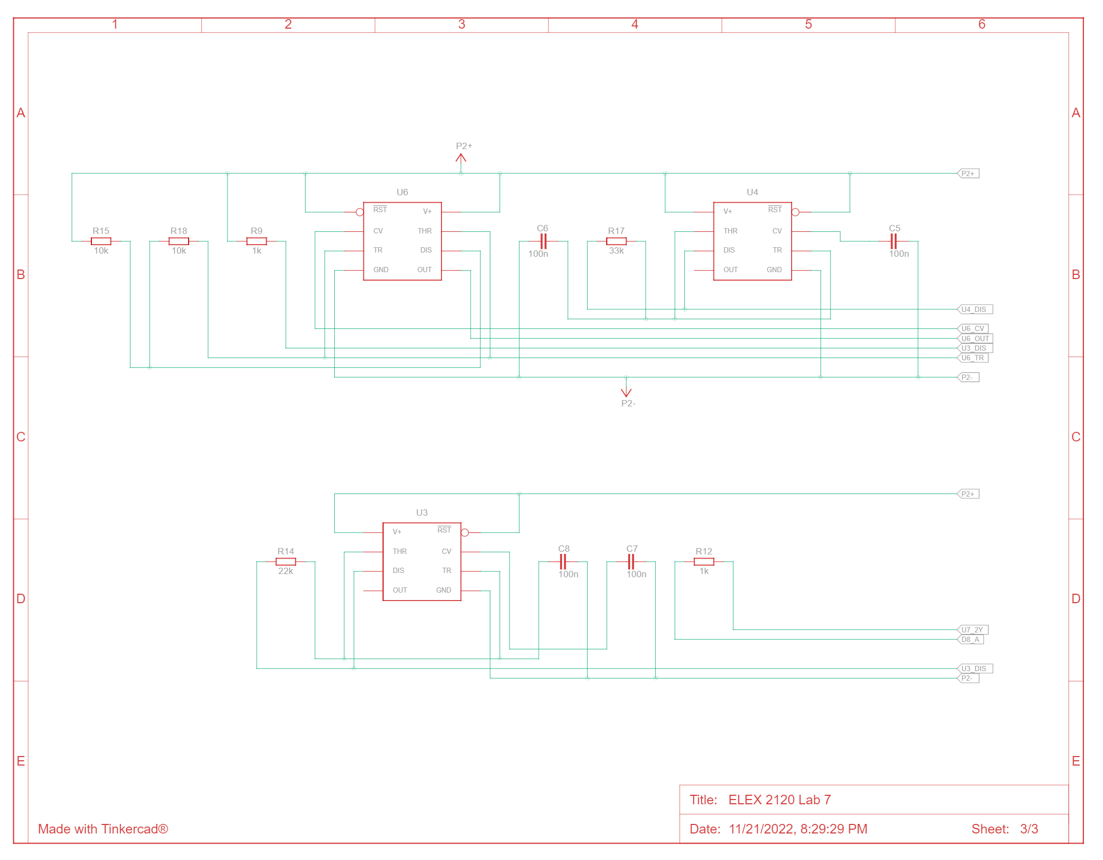

*Figures 2-4 –Schematic for the blinking LEDs*

# Arduino Uno

The next step is using an Arduino Uno to control all the units of our circuit. The Arduino Uno has onboard a +5V supply voltage to power our circuit. It can be easily powered by a +9V battery which we can attach to the car.

The microcontroller can be programmed to receive inputs from the IR remote. It will then output the necessary signals to control the H-Bridge IC, turn on the LED indicators, and make sound. We can then also add additional ultrasonic sensors for collision detection.

*Figure 5 – Arduino Uno with ultrasonic sensors, IR receiver diode, and remote*

*Figure 6-7 – Schematics of Arduino with ultrasonic sensors, IR remote control*

## Collision avoidance

Our next enhancement is using the HCS404 ultrasonic sensors to detect the distance between the car and any potential obstacles to avoid. Based on the detected distance, we can make the car stop or go in the opposite direction if it gets too close to a wall or obstacle. Two sensors can be used to detect obstacles near the front and back of the car.

For example, if the car is 6 cm away from hitting a wall, it will stop and won’t move in that direction.

## IR remote control

Our last enhancement is implementing IR remote control for our robot car. This will make controlling the car more convenient than having to pick it up and flick a switch.

The IR receiver diode will pick up infrared signals sent from the IR remote. Each infrared signal is unique depending on the remote button pressed. The diode will input the signals to the Arduino to then control the direction of the car. We can thus operate make basic remote-controlled car.

If we can the IR remote to work properly, the remote buttons will serve to control the car. The Grayhill switch will then be unnecessary and can be removed.